**Lab 4: Install and Configure WSUS Server on Windows Server 2019**

**Lab Topology:**

*Note: VM already set up during your labs 1, 2, and 3.*

* **Host Name:** IT2-DC01
  + **Role:** AD DS, DNS & DHCP
  + **Domain:** NORTHERNCOLLEGE.LOCAL
* **Machine 2:**
  + **Host Name:** IT2-WSUS
  + **Role:** WSUS Server
  + **RAM:** 1 GB
  + **Domain:** NORTHERNCOLLEGE.LOCAL
  + *Note: Set up the new VM as you have already done for the WDS server.*

**Tasks and Requirements:**

**Task 1:**

* Perform basic settings on the VM and join the server to the domain.
* **Screenshot Required:**
  + IPv4 settings in the network adapter
  + Machine added to the domain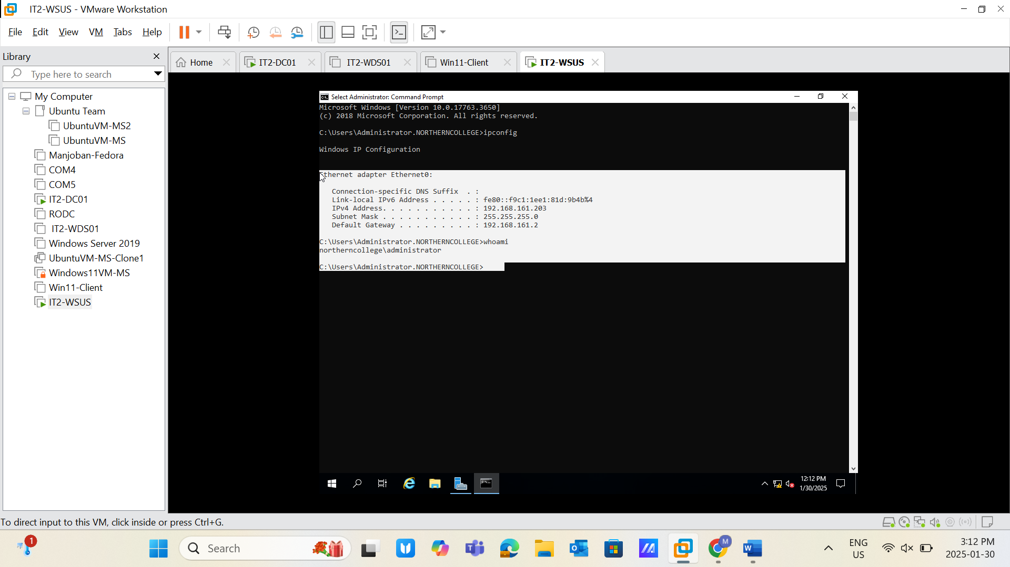

**Task 2:**

* Move the server into the Organizational Unit: Servers under CANADA in Active Directory Users and Computers.
* **Screenshot Required:** Task completion evidence. 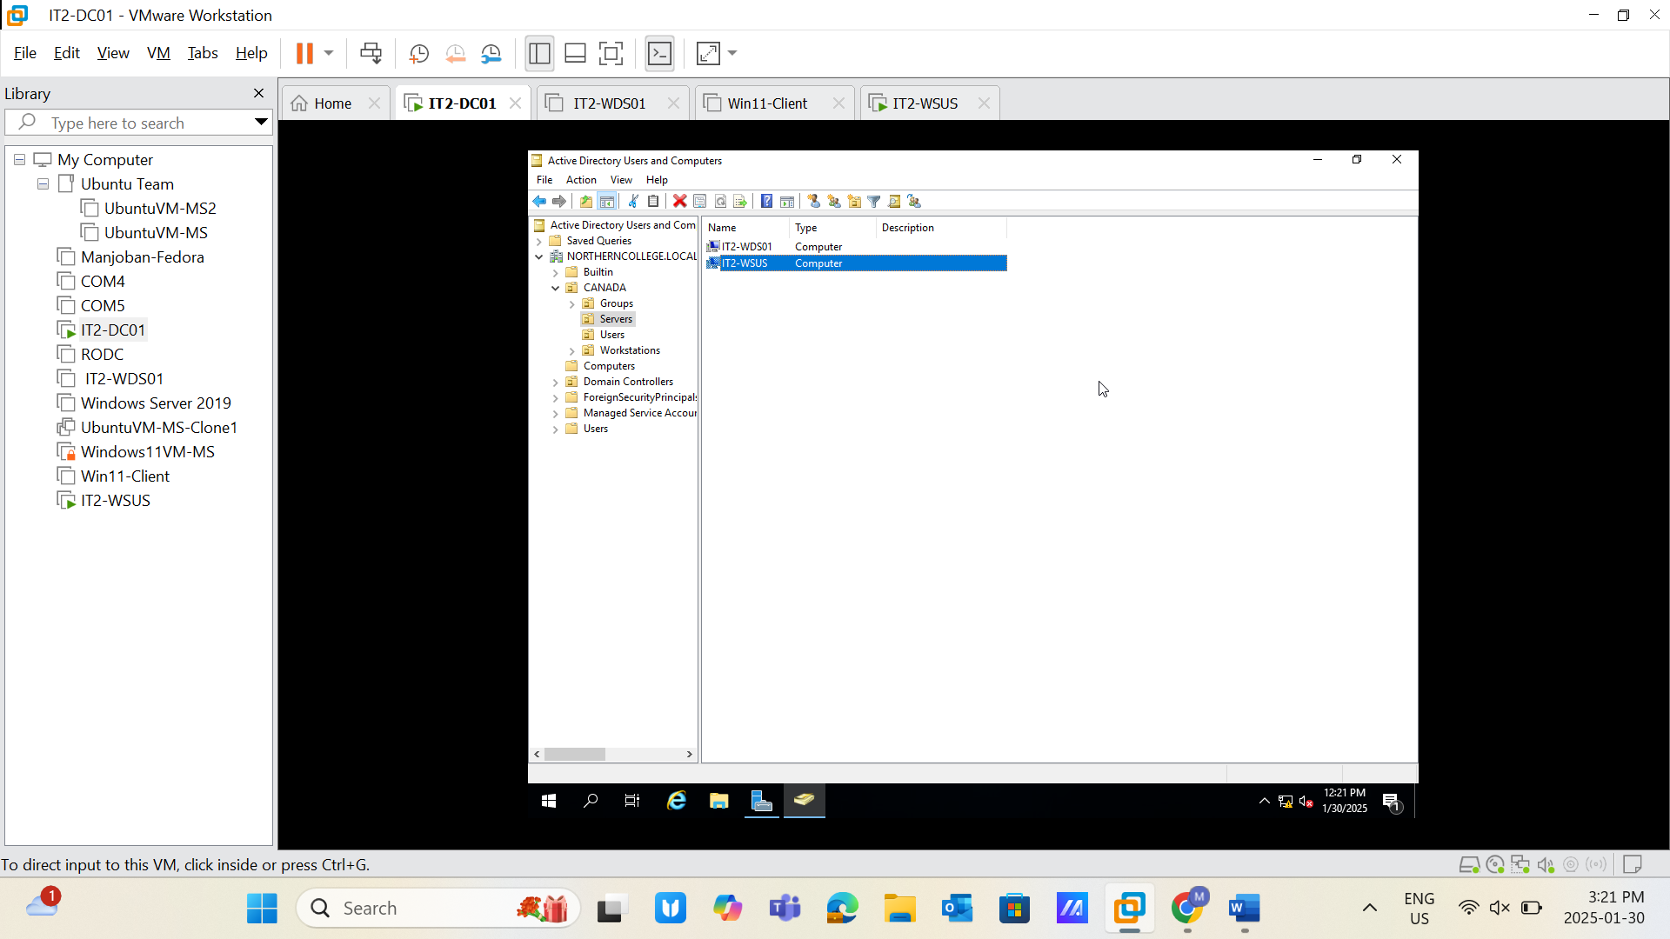

**Task 3:**

* Change the disk drive to Z:
* Create a new volume: WSUS (D:).
* **Screenshot Required:** Task completion evidence. 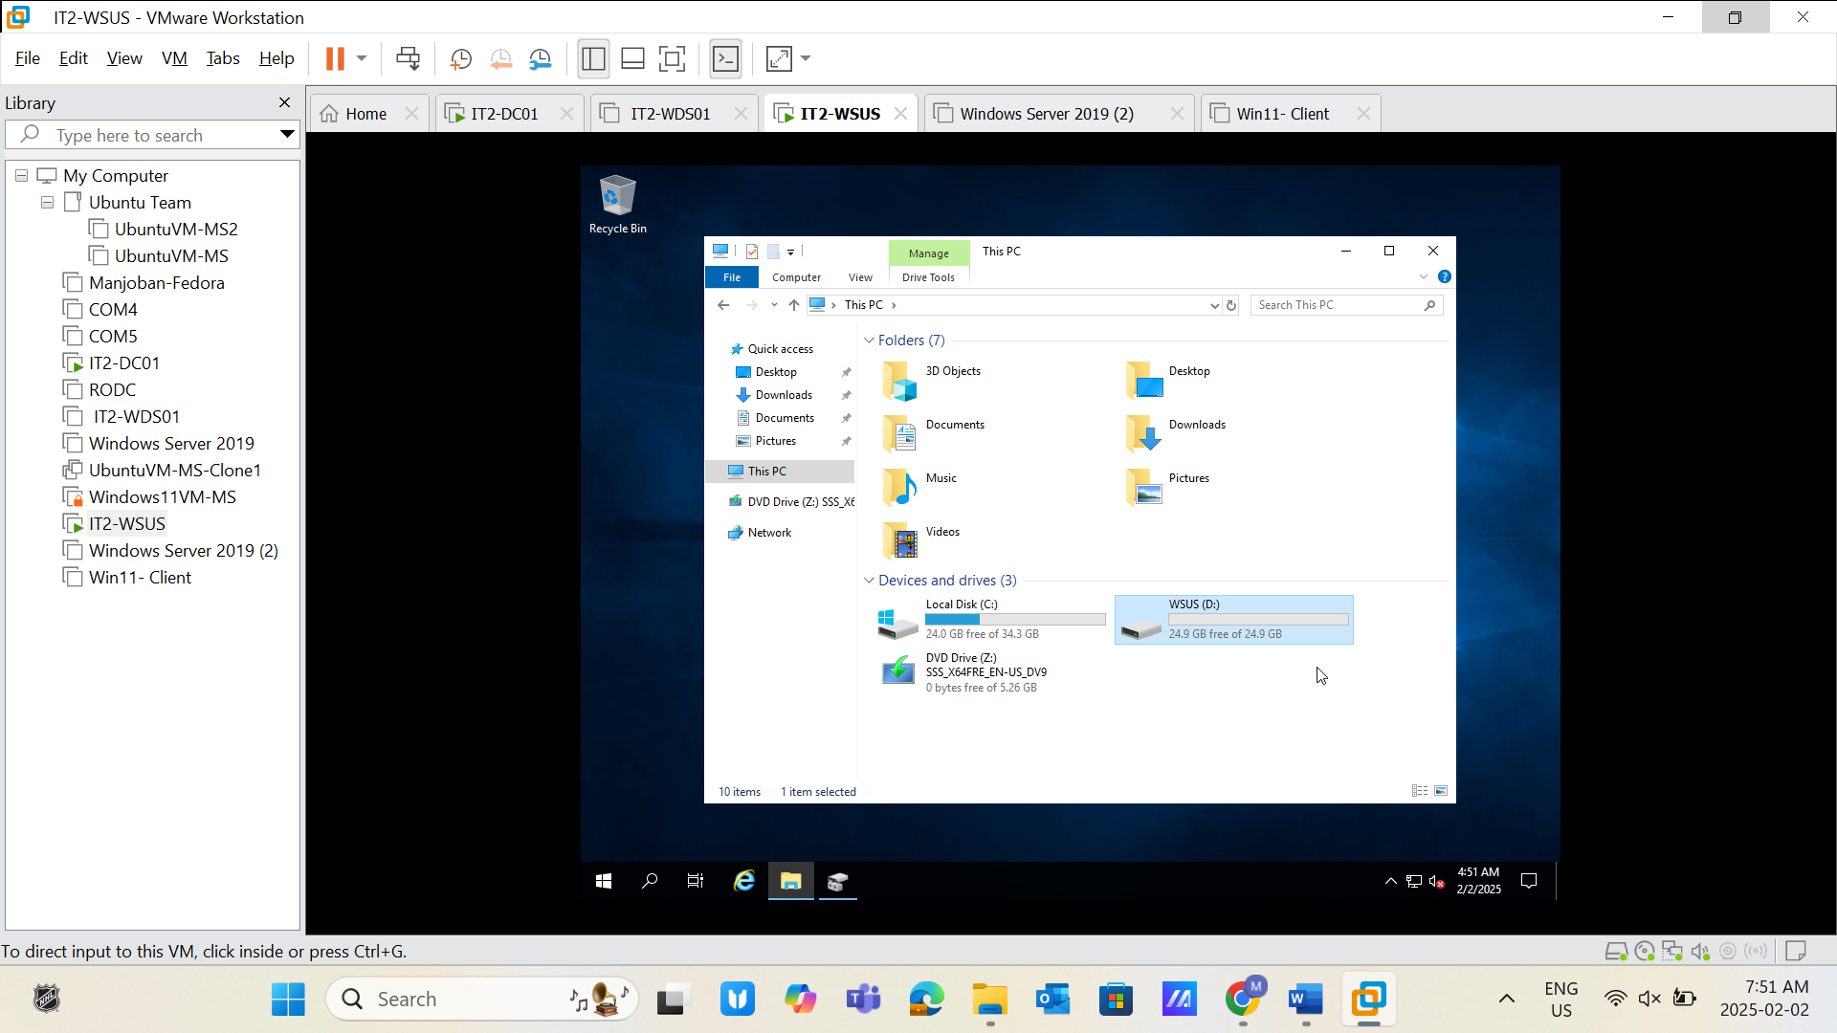

**Task 4:**

* Create a folder inside the WSUS volume: WSUS-Data. 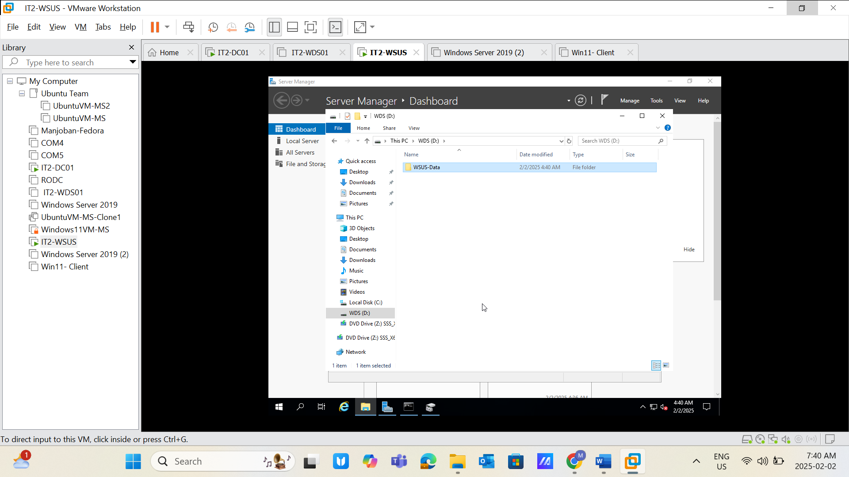
* Add the successful installation page for WSUS services in the Add Roles and Features Wizard.
* **Screenshot Required:** Task completion evidence. 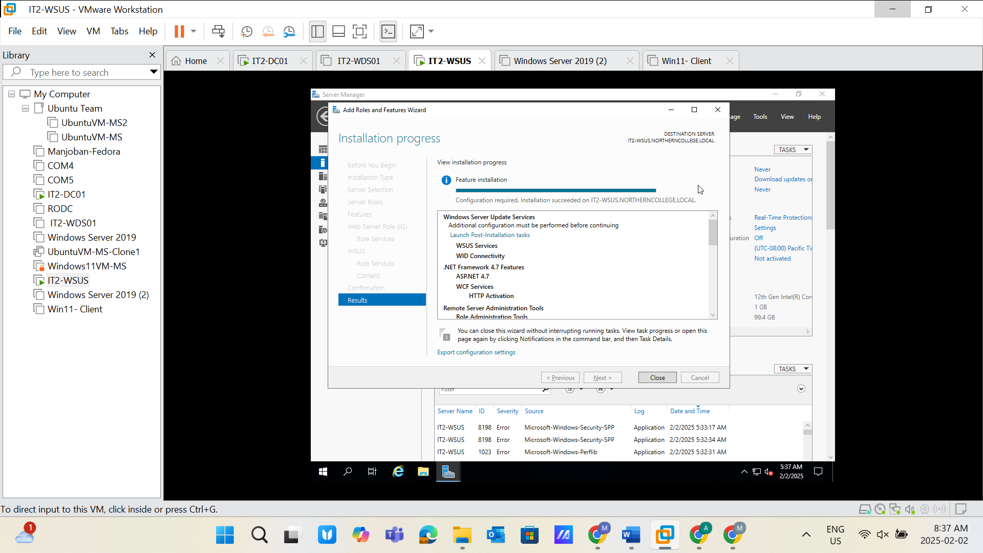

**Task 5:**

* Configure Group Policy for WSUS.
* **Screenshot Required:** Policy configuration evidence. 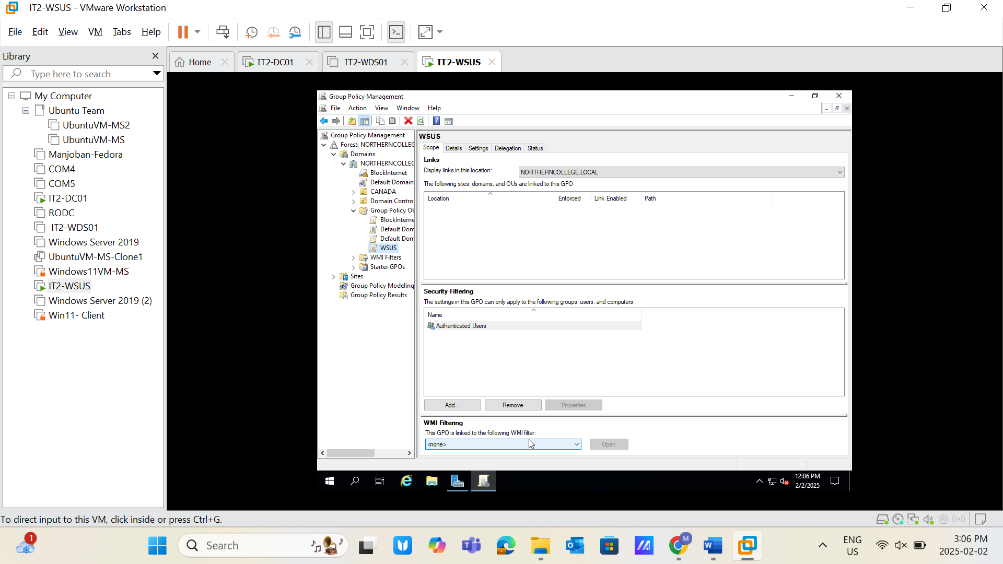

**Task 6:**

* Configure the "Specify Intranet Microsoft update service location" policy.
  + Pass: http://IT2-WSUS.NORTHERNCOLLEGE.LOCAL:8530
* **Screenshot Required:** Task completion evidence. 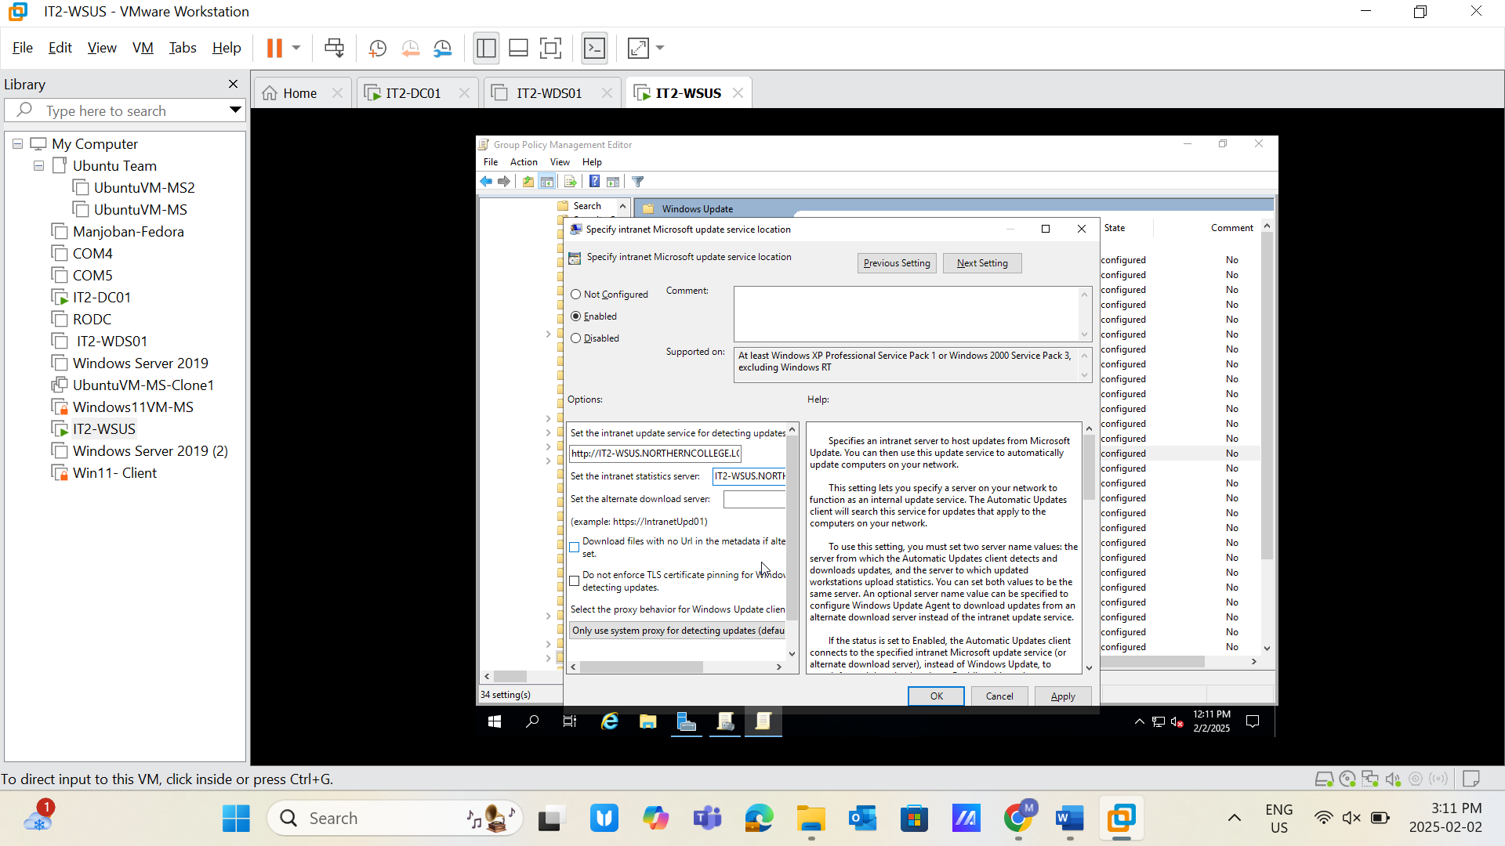

**Task 7:**

* Configure the "Automatic Updates detection frequency" policy.
  + Set Interval: 1 Hour
* **Screenshot Required:** Task completion evidence. 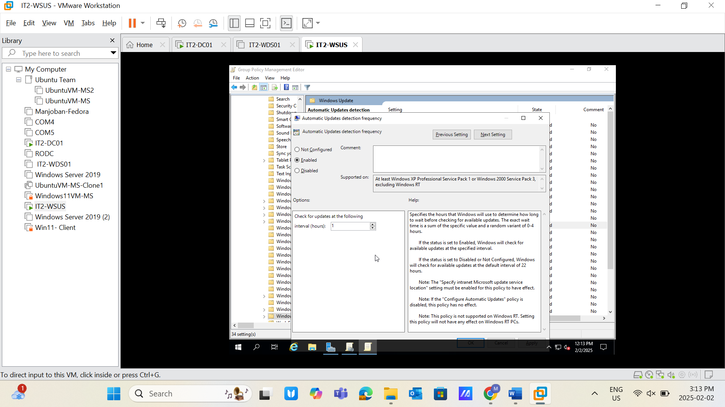

**Task 8:**

* Configure the "Turn off auto-restart for updates during active hours" policy.
  + Set Active Hours: Start: 6 AM; End: 9 PM
* **Screenshot Required:** Task completion evidence. 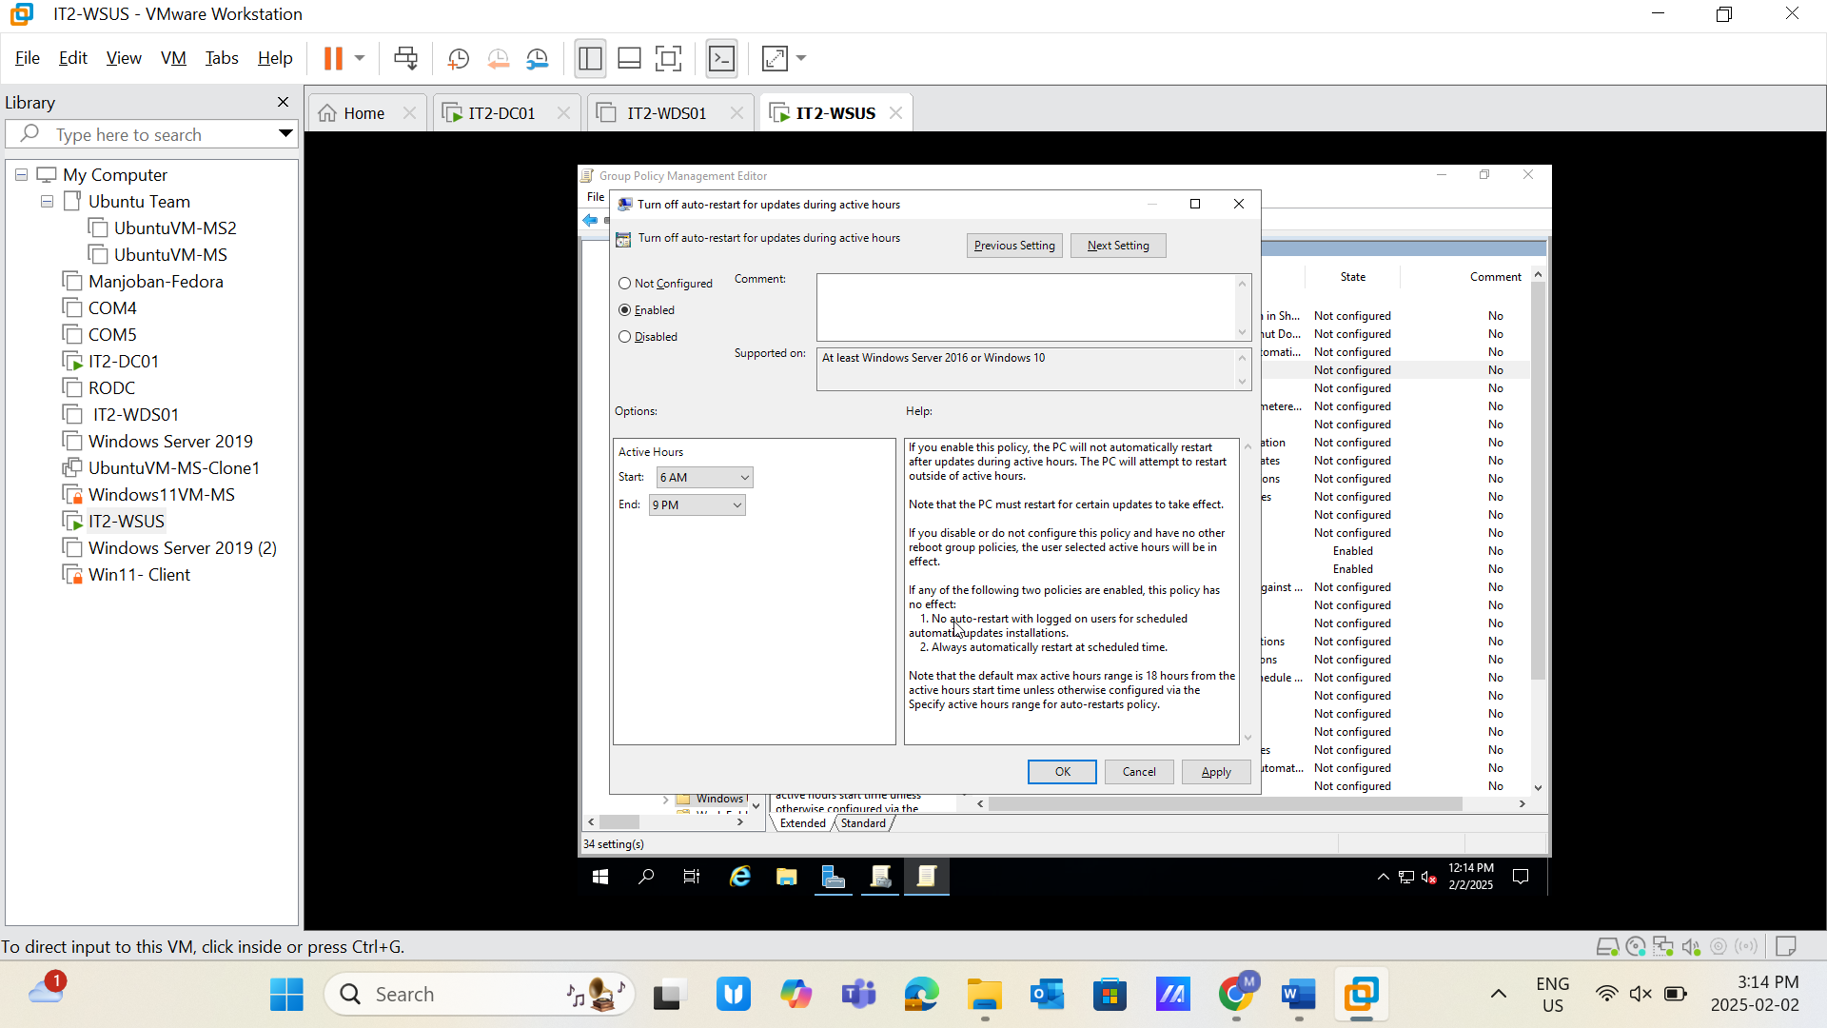

**Task 9:**

* Configure the "Specify active hours range for auto-restarts" policy.
  + Max Range: 12 Hours
* **Screenshot Required:** Task completion evidence. 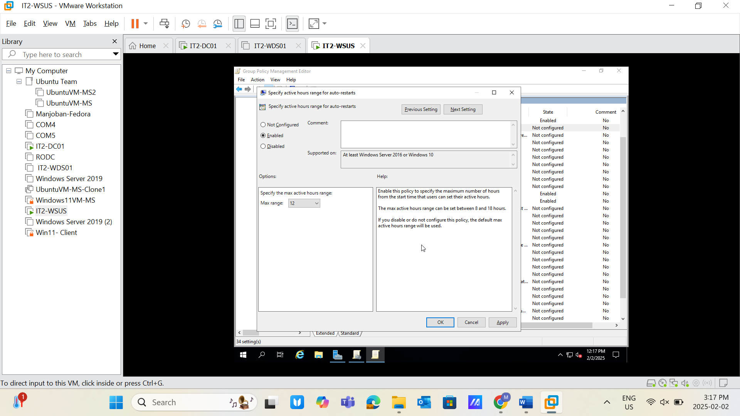

**Task 10:**

* Configure the "Always automatically restart at the scheduled time" policy.
  + Work Minutes: 30 Minutes
* **Screenshot Required:** Task completion evidence. 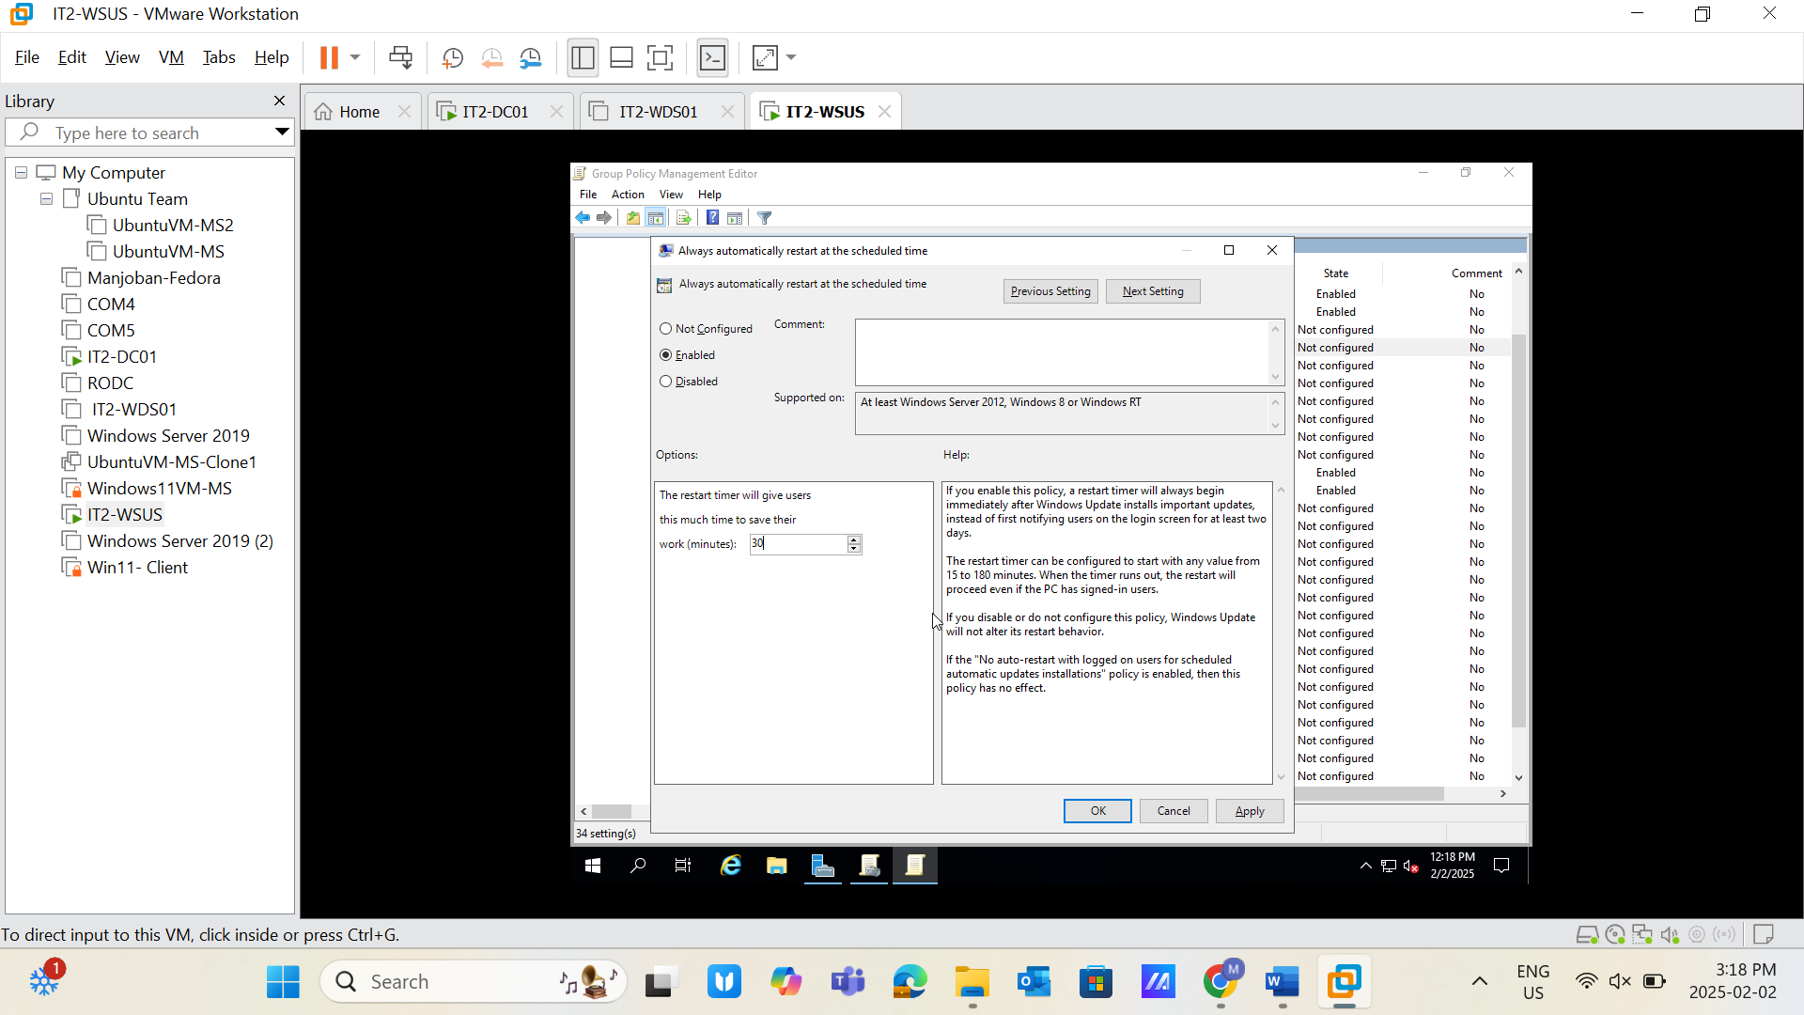

**Task 11:**

* Configure the "Configure Automatic Updates" policy.
  + Configure Automatic Updating: 4. Auto download and schedule the install
  + Select: Install during automatic maintenance
  + Schedule Install Time: 01:00
  + Select: Install updates for other Microsoft products
* **Screenshot Required:** Task completion evidence. 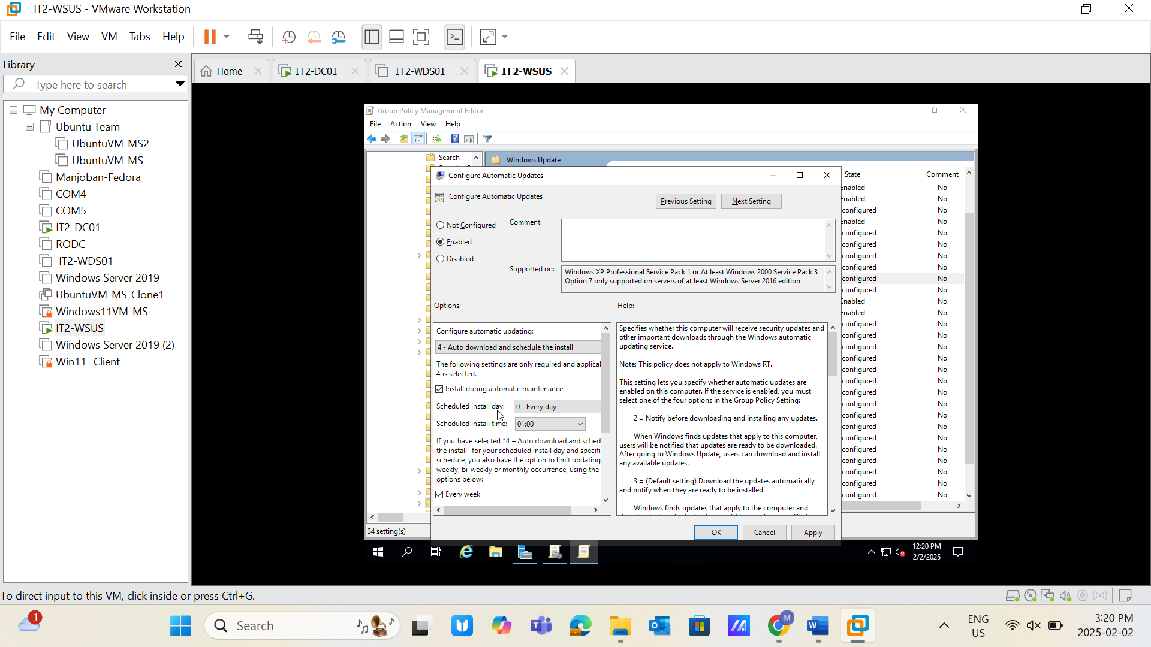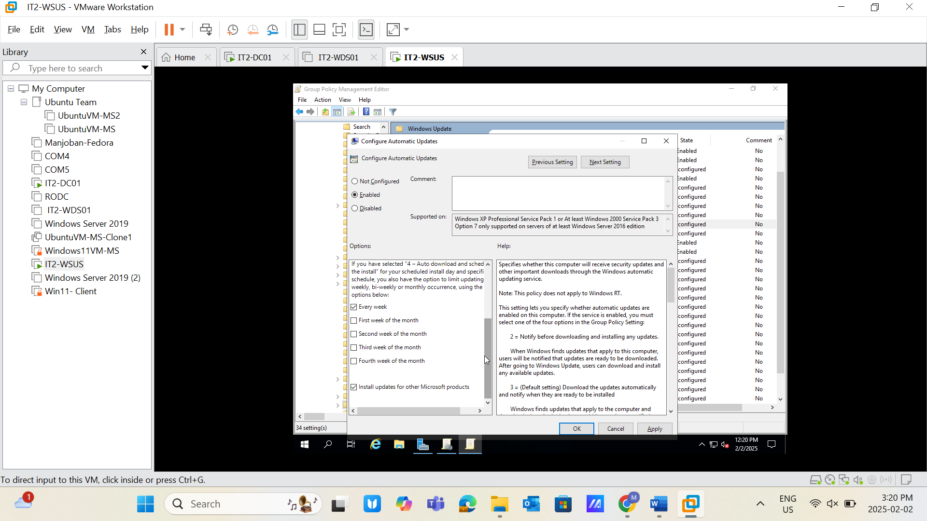

**Task 12:**

* Link the GPO created (WSUS) and apply the policy.
* **Screenshot Required:** Policy application evidence. 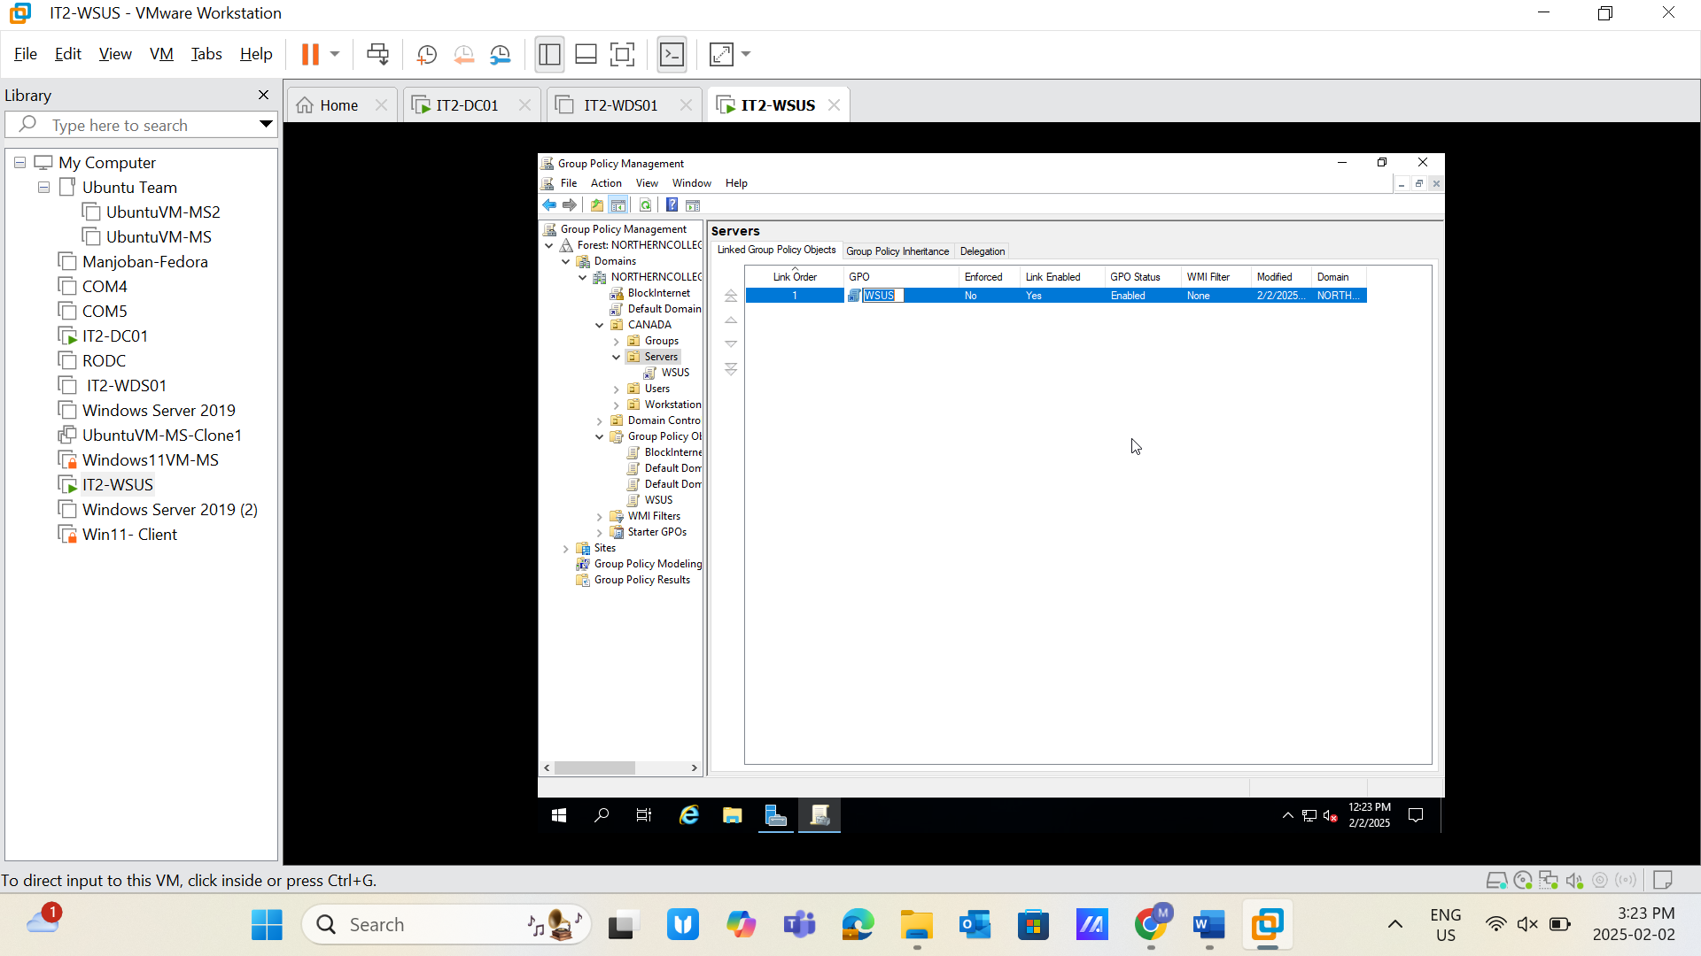

**Task 13:**

* Upload a screenshot showing "Post-deployment Configuration: Complete."
* **Screenshot Required:** Task completion evidence. 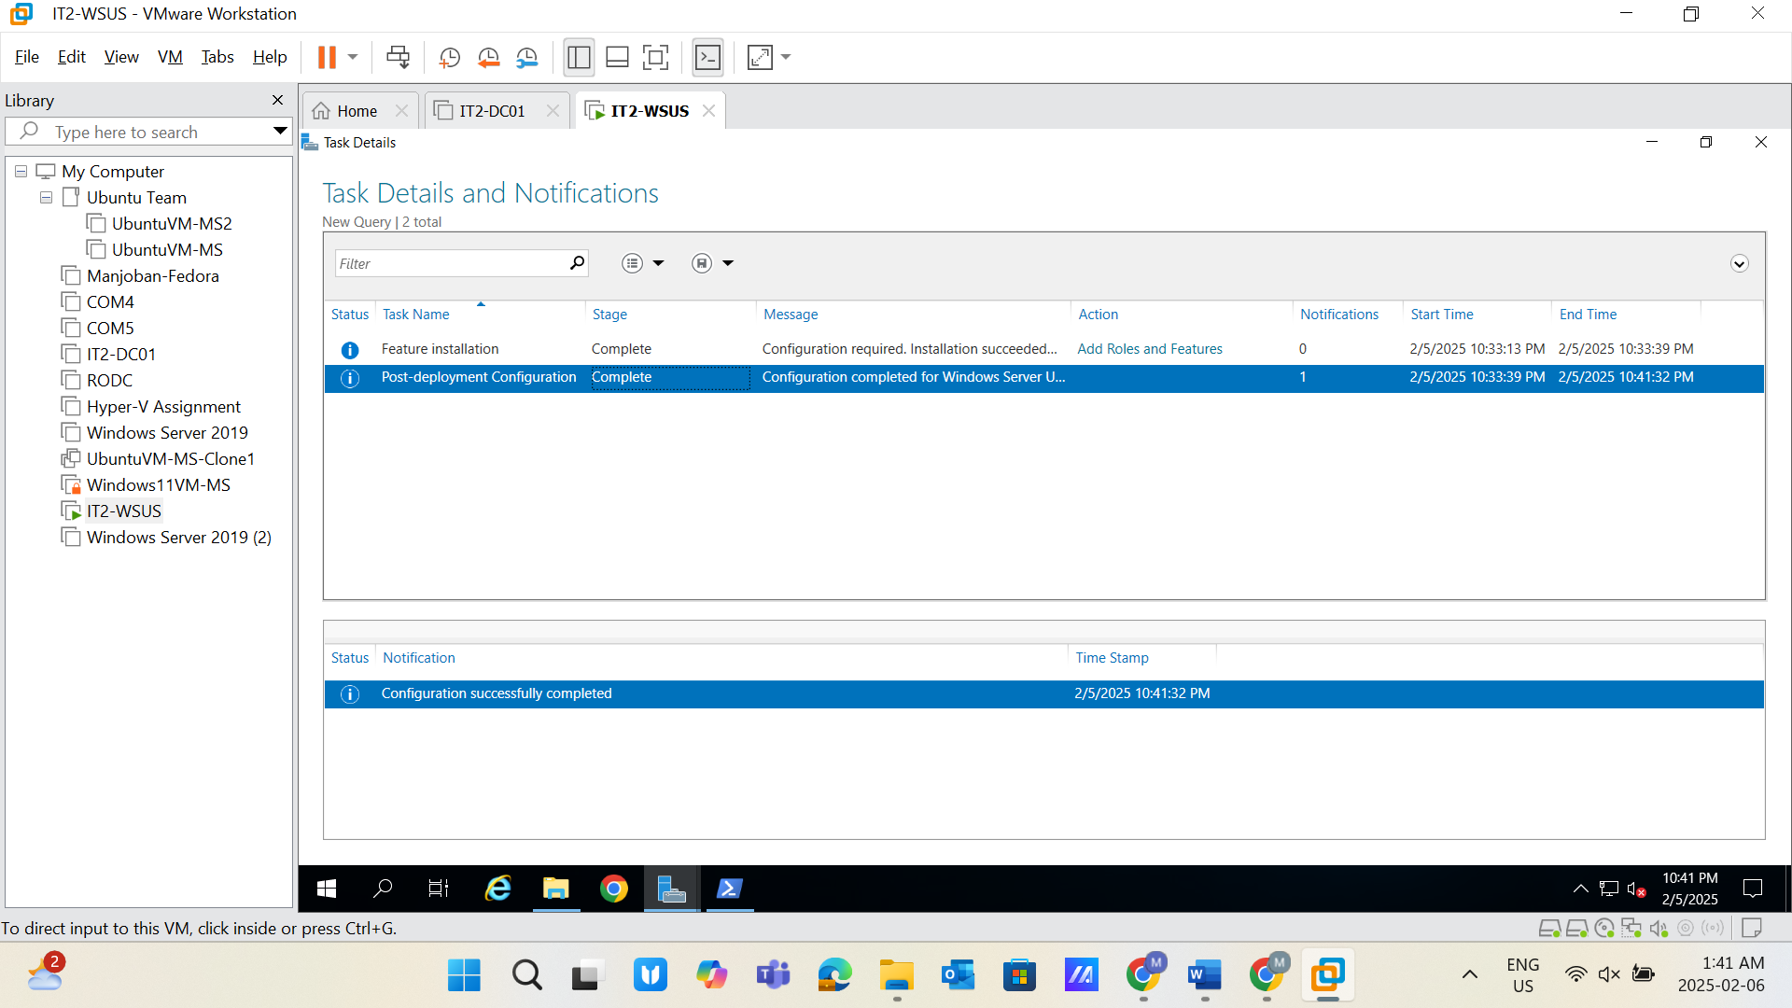

**Task 14:**

* Upload screenshots of each step in the "Windows Server Update Services Configuration Wizard."
* Upload synchronization status snapshot from the Update Services section.
* **Screenshot Required:** Task completion evidence. 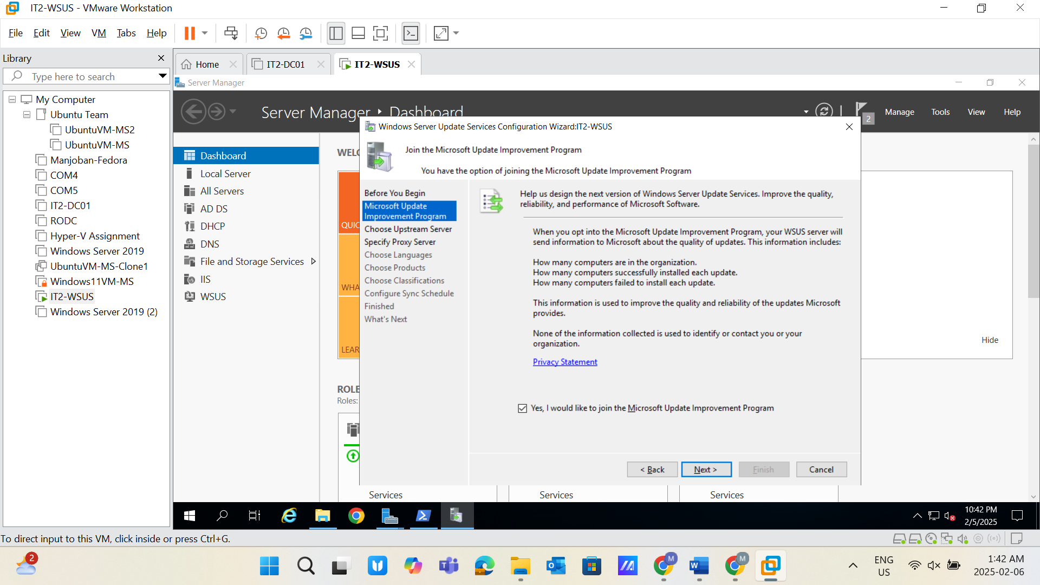 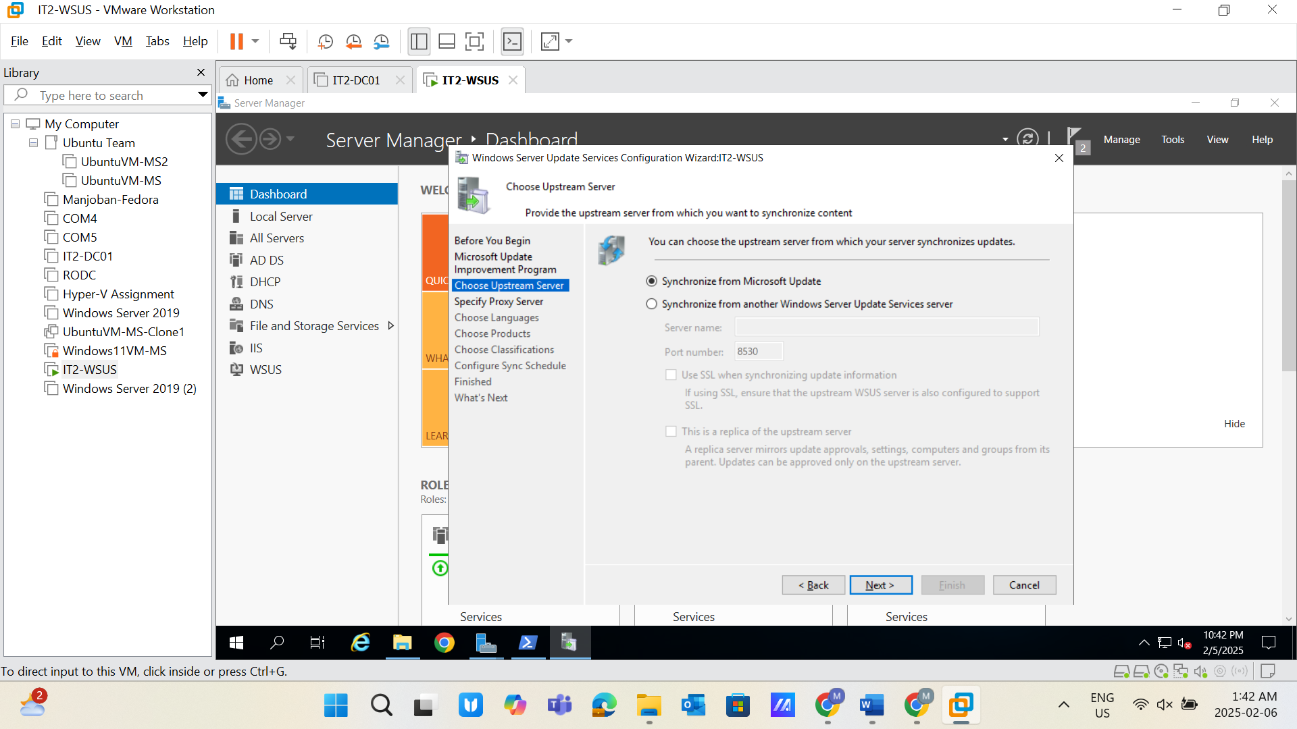 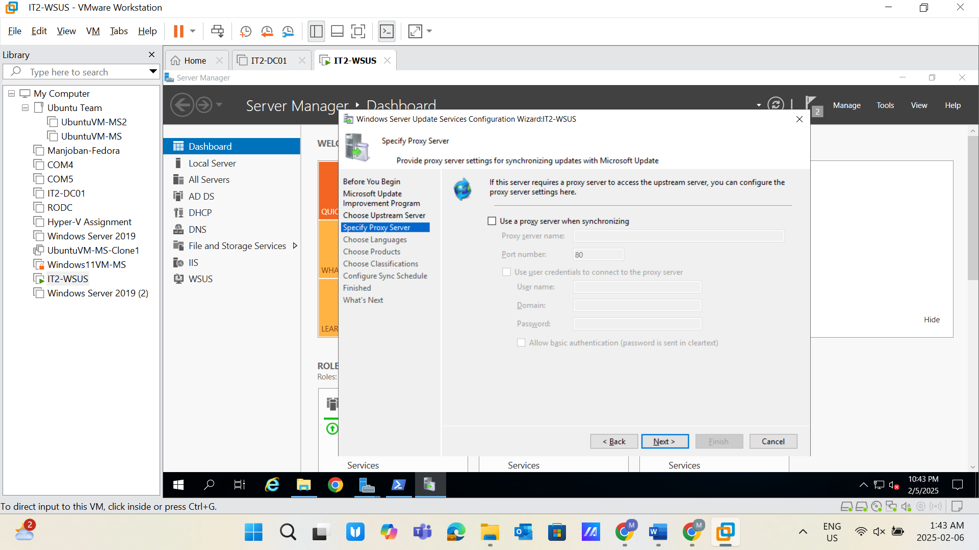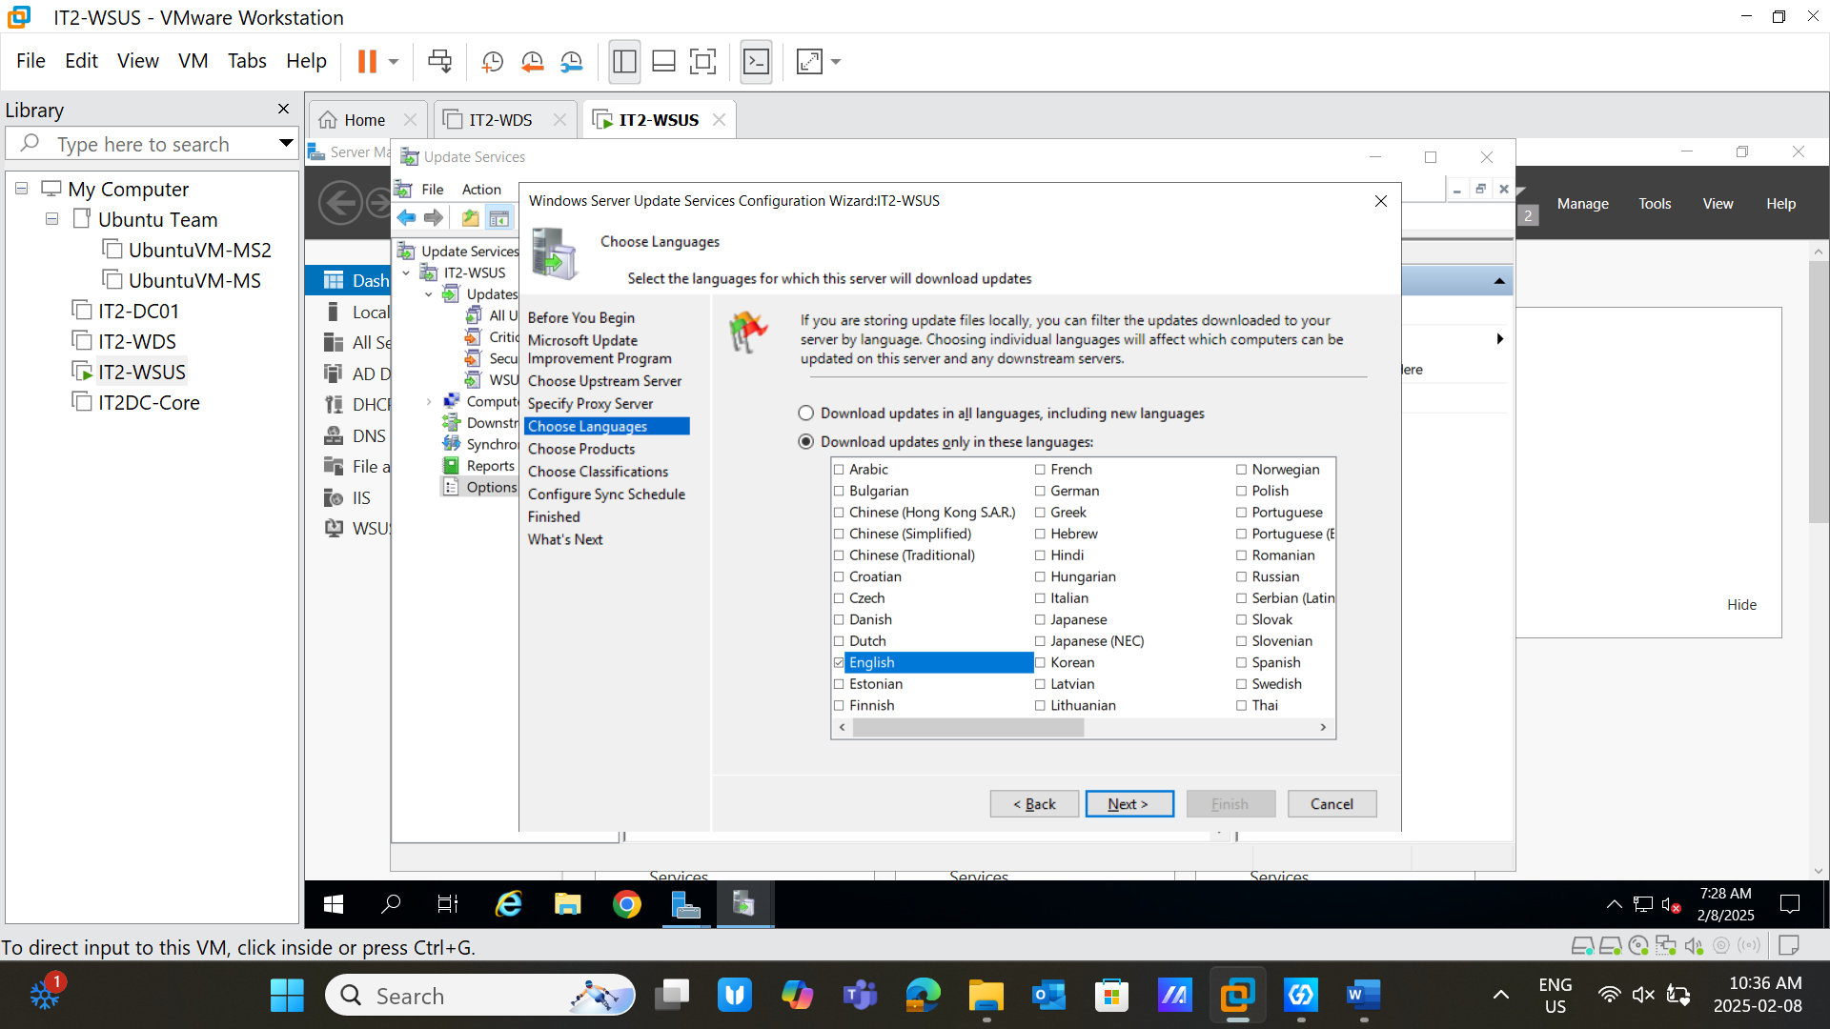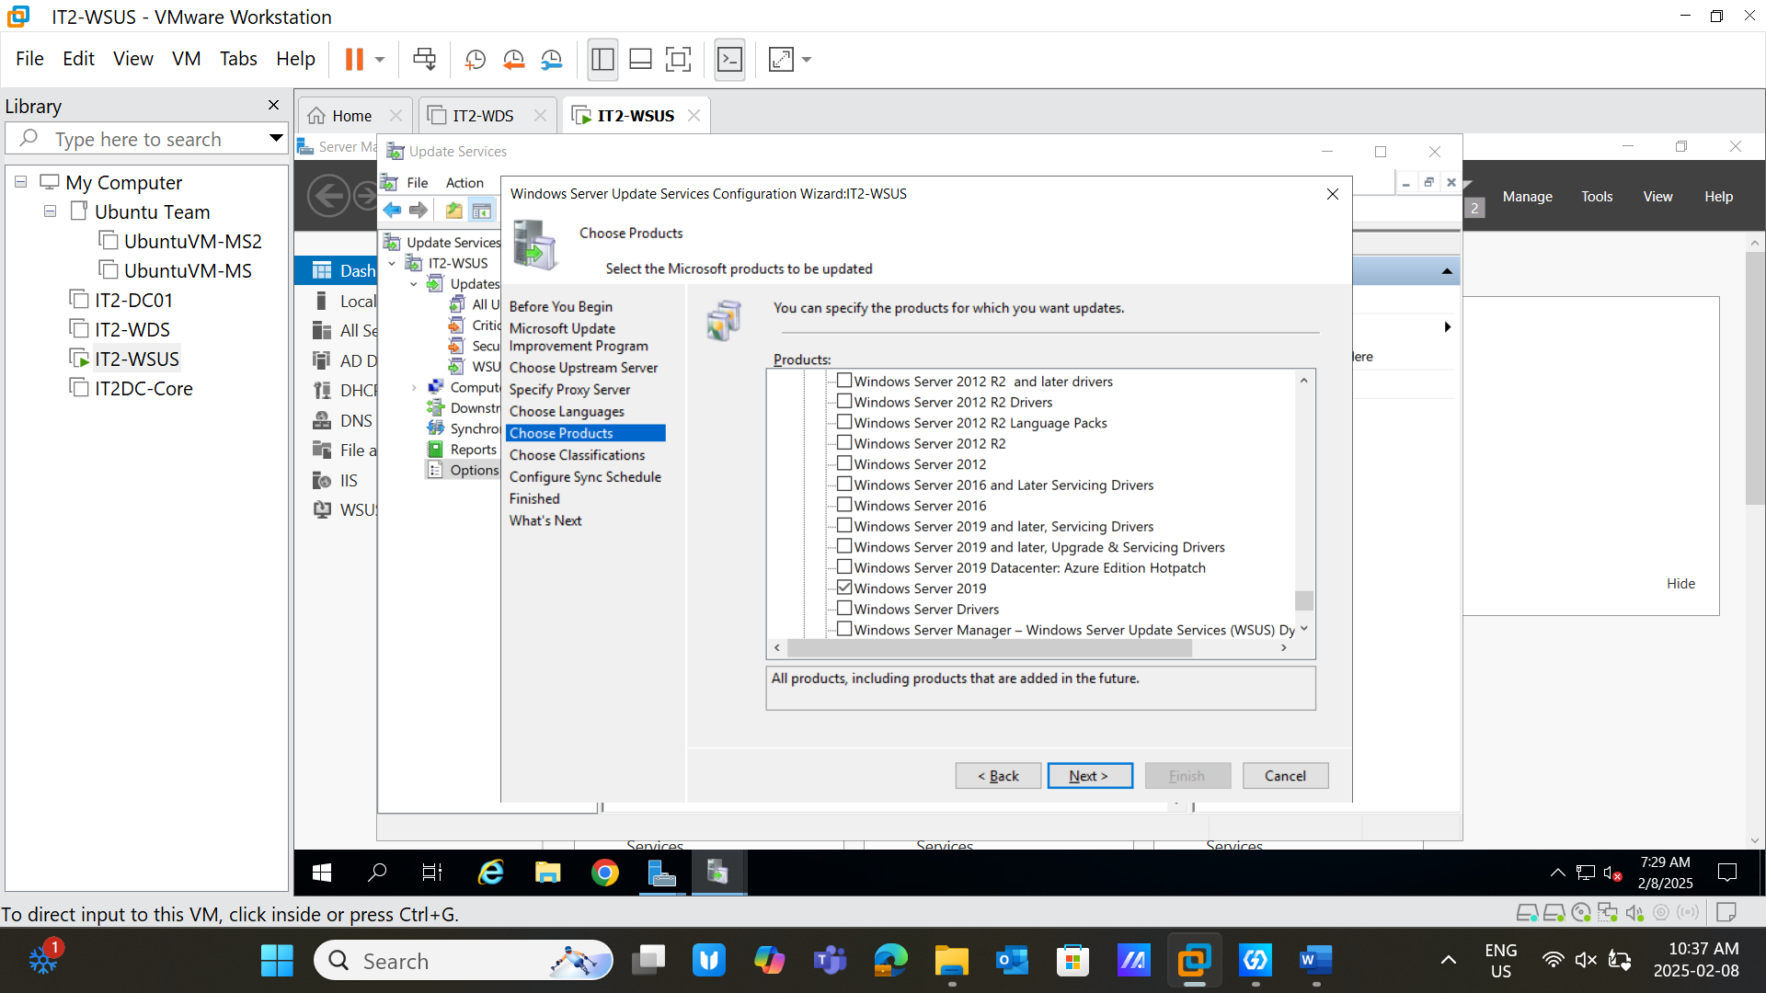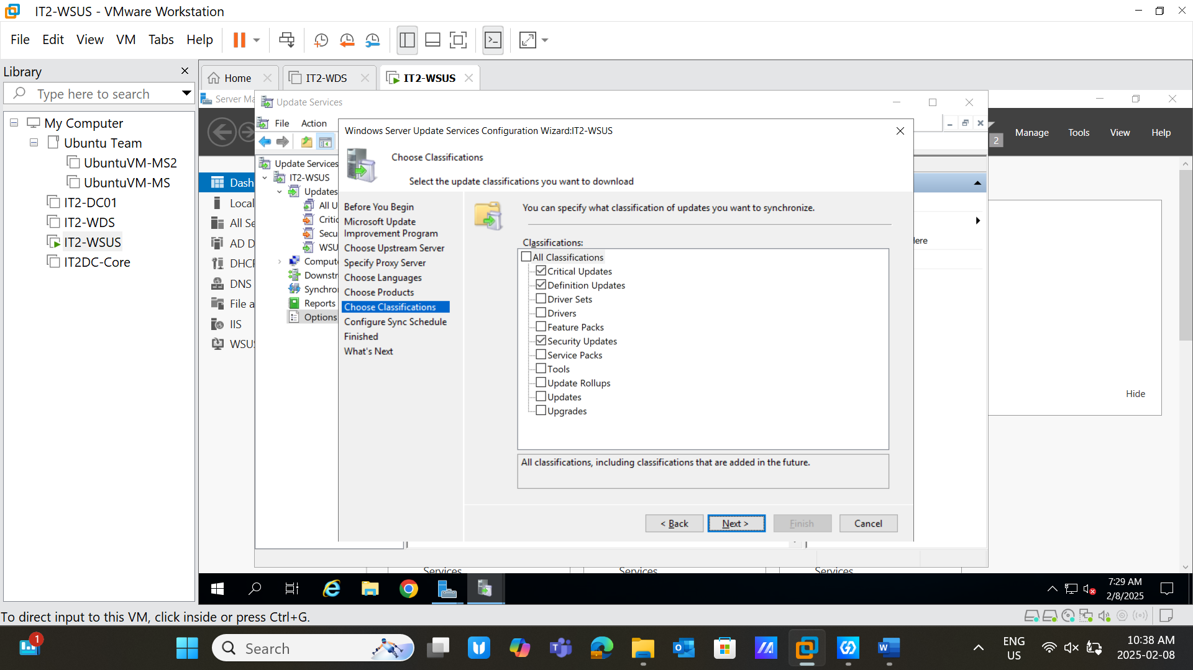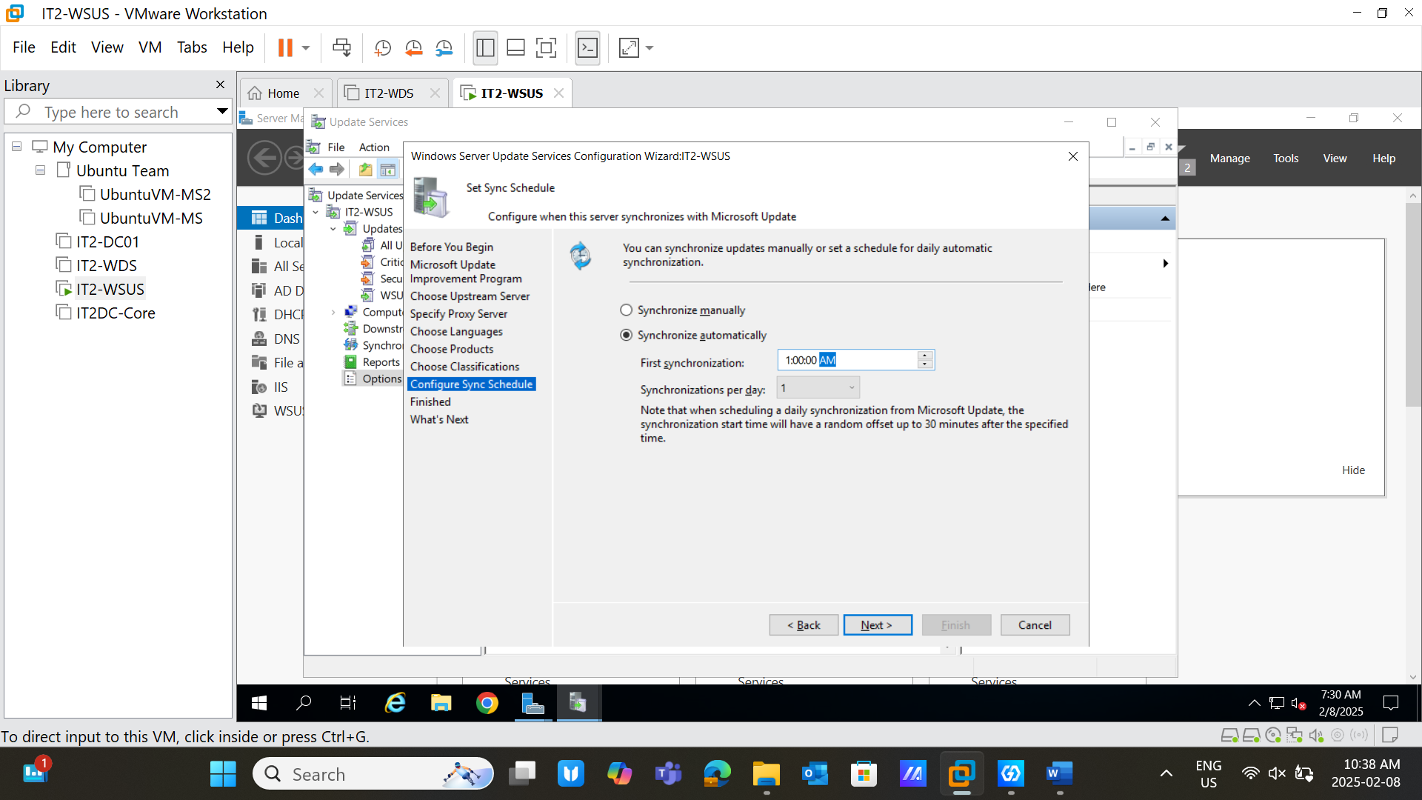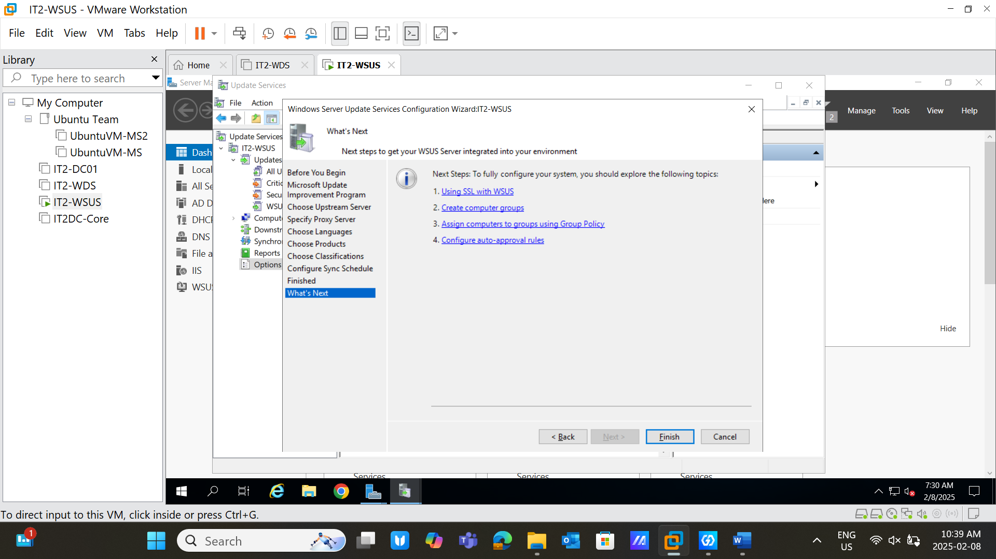 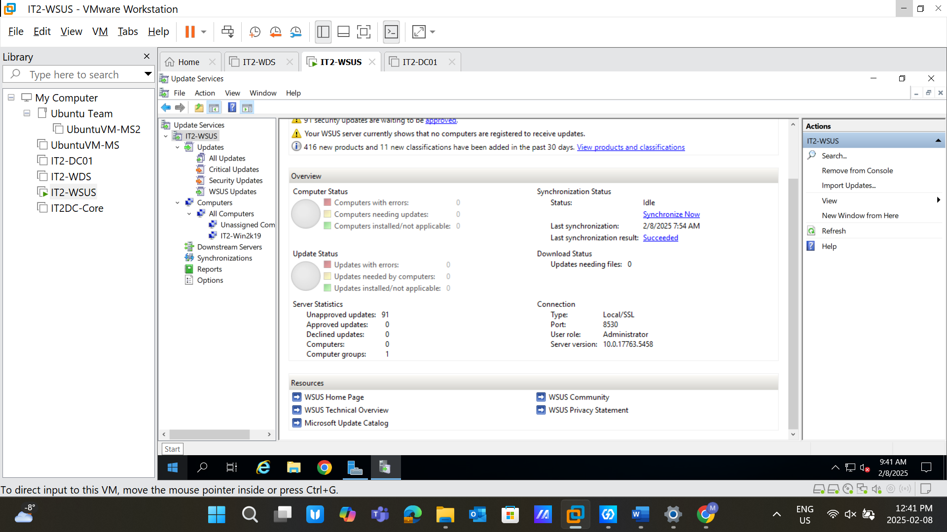

**Task 15:**

* Create Group: IT2-Win2k19 and change the membership of computers into it.
* **Screenshot Required:** Task completion evidence. 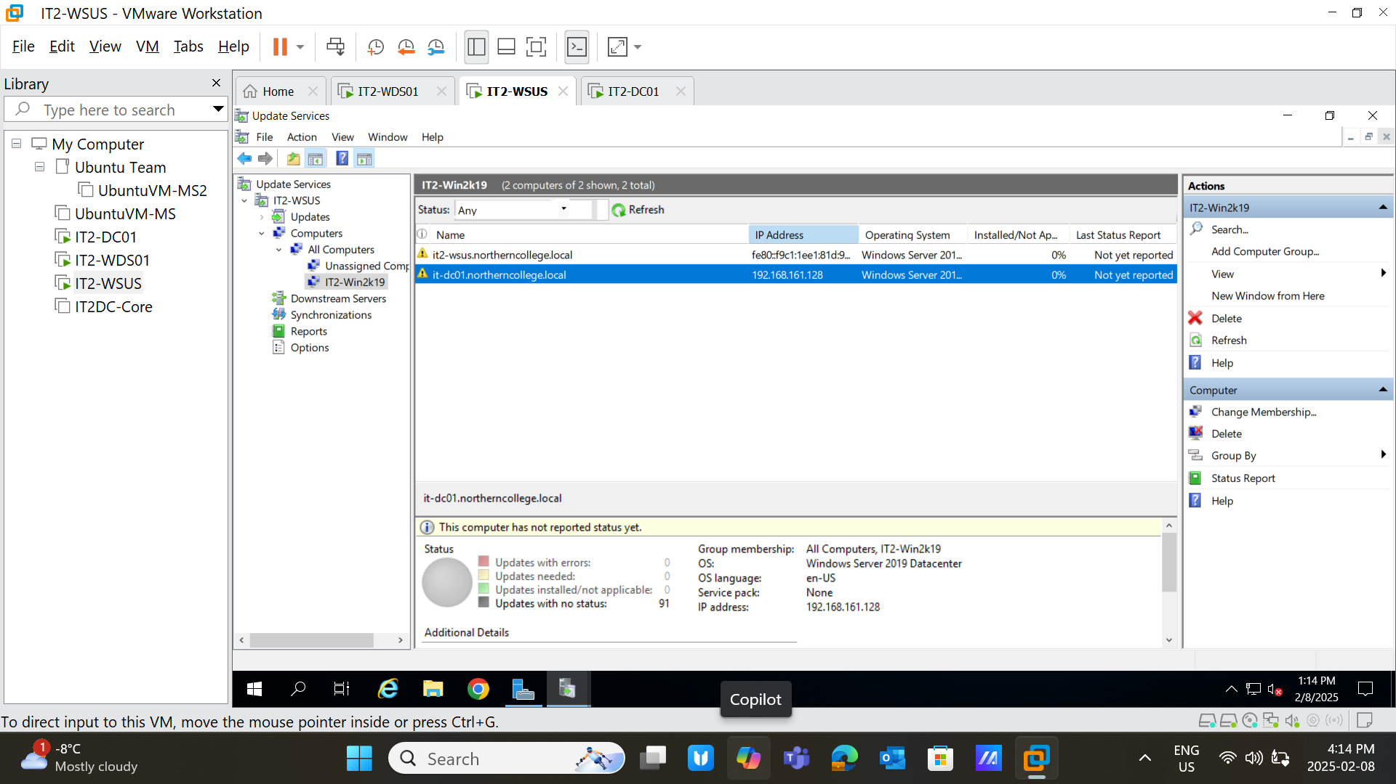

**Task 16:**

* Take a snapshot of all unapproved updates (before). 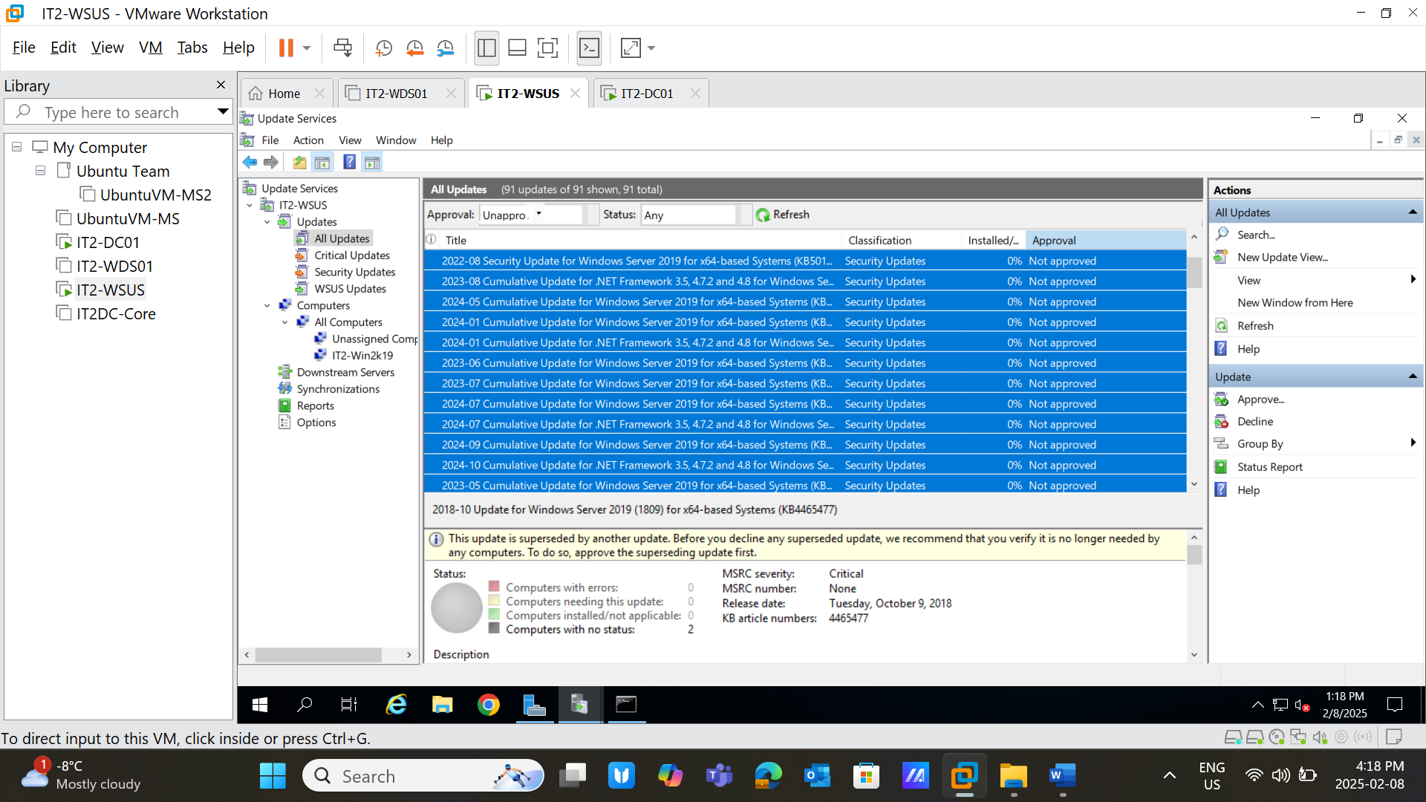
* Approve all updates and take another snapshot (after). 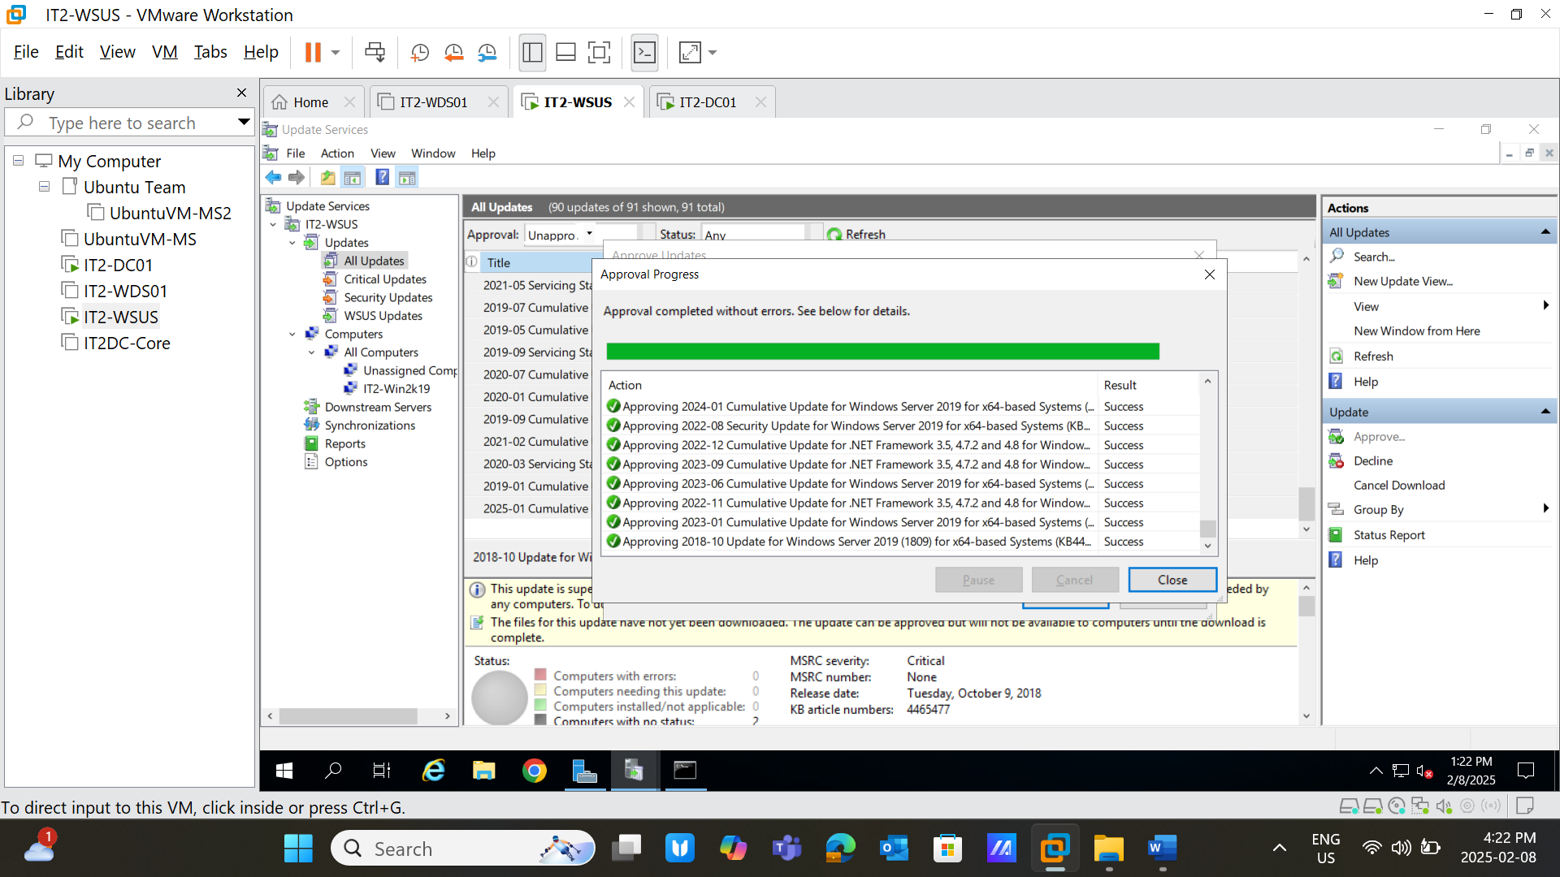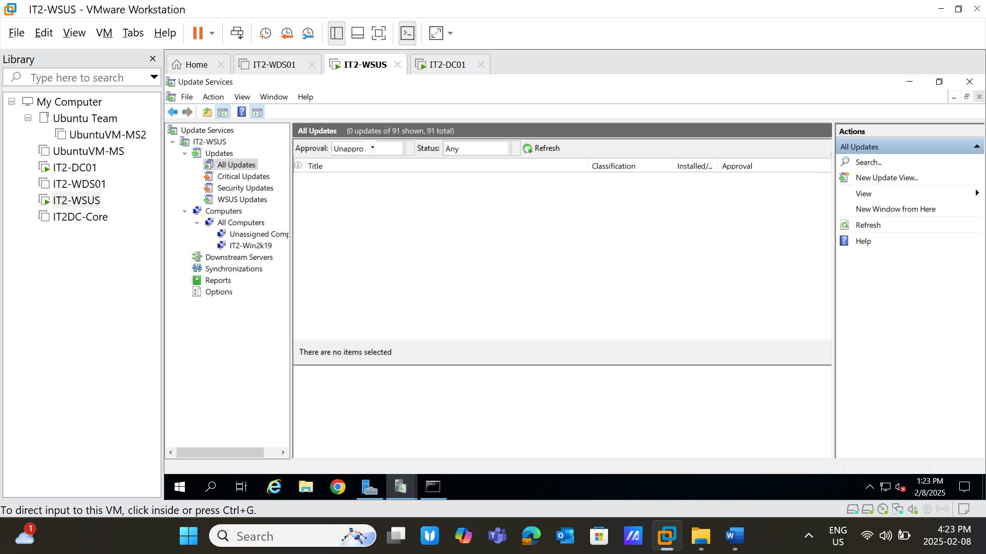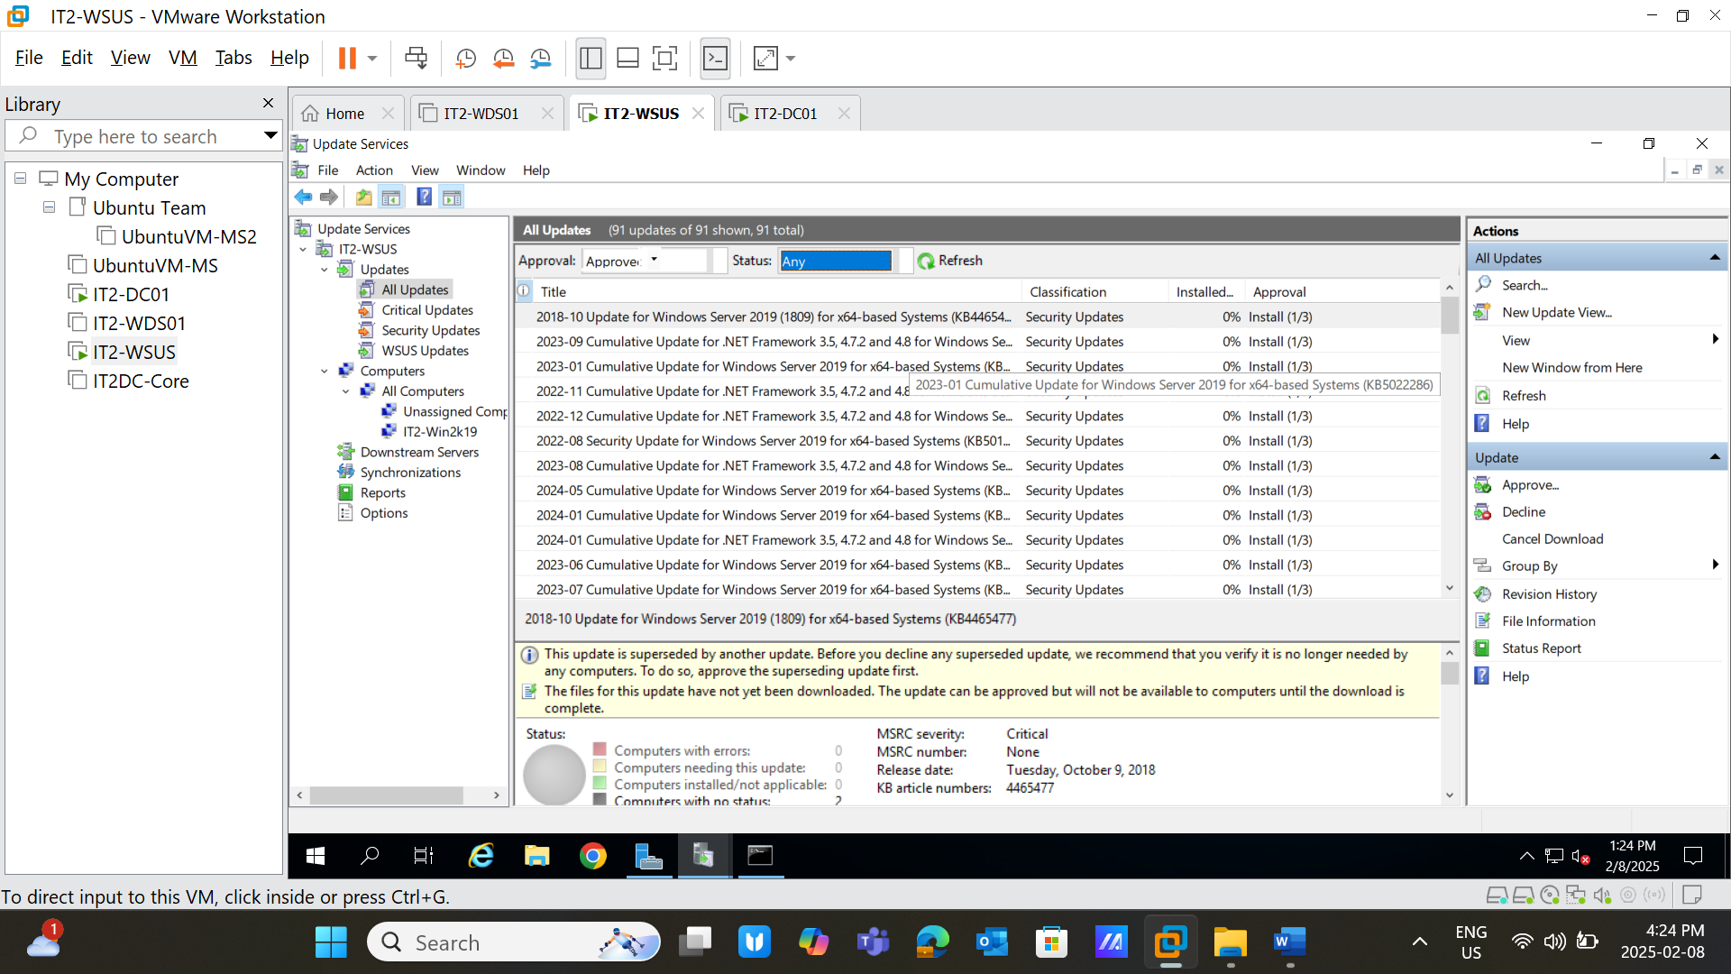
* **Screenshot Required:** Task completion evidence.